**Documentation**

**Online Learning-Web Development:**

This domain focuses on providing comprehensive educational content and resources for individuals interested in learning and mastering web development skills. This domain encompasses a wide range of courses and learning materials designed to cater to learners at various skill levels, from beginners to advanced practitioners. Learners can access the content remotely through an online platform, allowing for flexible and self-paced learning.

The Online Learning - Web Development domain is highly relevant in the current digital landscape for several reasons:

* In-Demand Skills: Web development skills are crucial in the digital era as businesses increasingly rely on digital platforms.
* Flexible Learning: Online learning provides flexibility, enabling individuals to acquire web development skills at their own pace and schedule.
* Career Opportunities: Mastery of web development opens doors to diverse roles like Front-End Developer, Back-End Developer, Full-Stack Developer, and Web Application Developer.
* Continuous Technological Evolution: Web development's dynamic nature requires continuous learning; online platforms ensure learners stay updated with the latest tools and frameworks.
* Global Accessibility: Online learning removes geographical barriers, offering high-quality web development education to learners worldwide.
* Community Collaboration: Discussion forums and community engagement foster collaboration, networking, and knowledge-sharing among learners, enhancing the overall learning experience.

**ER Diagram:**

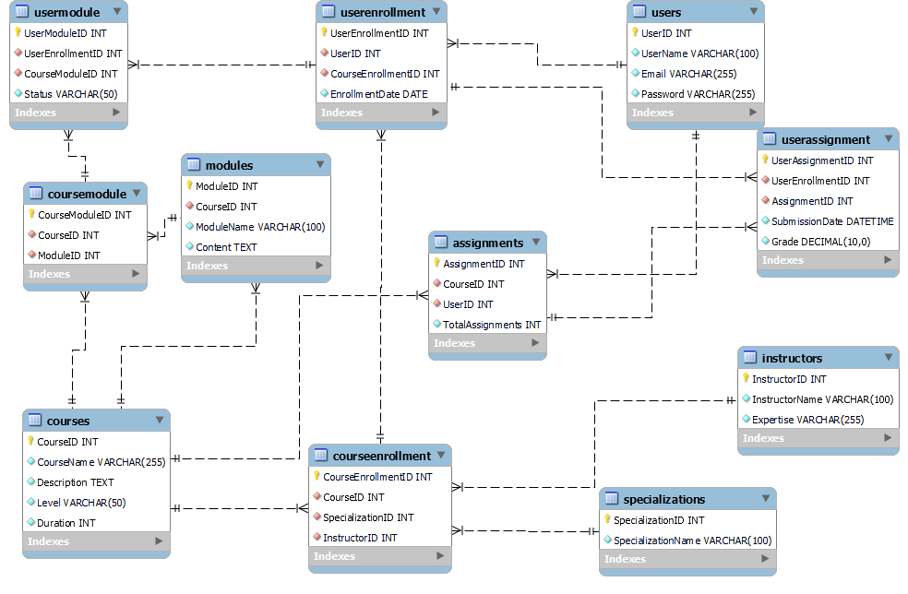

Table Name: courses

Table Description: Table contains the course details of each course.

|  |  |  |
| --- | --- | --- |
| **Field** | **Datatype** | **Constraints** |
| CourseID | int | Primary Key, Not Null, Unique |
| CourseName | varchar(255) | Not Null |
| Description | text | Not Null |
| Level | varchar(50) | Not Null |
| Duration | int | Not Null |

Table Name: instructors

Table Description: Table containing instructors details and what the course they are specialized in.

|  |  |  |
| --- | --- | --- |
| **Field** | **Datatype** | **Constraints** |
| InstructorID | int | Primary Key, Not Null, Unique |
| InstructorName | varchar(100) | Not Null |
| Expertise | varchar(255) | Not Null |

Table Name: specializations

Table Description: Table contains the specialization details.

|  |  |  |
| --- | --- | --- |
| **Field** | **Datatype** | **Constraints** |
| SpecializationID | int | Primary Key, Not Null, Unique |
| SpecializationName | varchar(100) | Not Null |

Table Name: users

Table Description: Table contains the user details such as email and password.

|  |  |  |
| --- | --- | --- |
| **Field** | **Datatype** | **Constraints** |
| UserID | int | Primary Key, Not Null, Unique |
| UserName | varchar(100) | Not Null |
| Email | varchar(255) | Not Null |
| Password | varchar(255) | Not Null |

Table Name: modules

Table Description: Table contains the module details of each course.

|  |  |  |
| --- | --- | --- |
| **Field** | **Datatype** | **Constraints** |
| ModuleID | int | Primary Key, Not Null, Unique |
| CourseID | int | Foreign Key, Not Null |
| ModuleName | varchar(100) | Not Null |
| Content | text | Not Null |

Table Name: assignments

Table Description: Table contains the assignment details of each course.

|  |  |  |
| --- | --- | --- |
| **Field** | **Datatype** | **Constraints** |
| AssignmentID | int | Primary Key, Not Null, Unique |
| CourseID | int | Foreign Key, Not Null |
| UserID | int | Foreign Key, Not Null |
| TotalAssignments | int | Not Null |

Table Name: courseenrollment

Table Description: This table

|  |  |  |
| --- | --- | --- |
| **Field** | **Datatype** | **Constraints** |
| CourseEnrollmentID | int | Primary Key, Not Null, Unique |
| CourseID | int | Foreign Key, Not Null |
| SpecializationID | int | Foreign Key, Not Null |
| InstructorID | int | Foreign Key, Not Null |

Table Name: userenrollment

Table Description:

|  |  |  |
| --- | --- | --- |
| **Field** | **Datatype** | **Constraints** |
| UserEnrollmentID | int | Primary Key, Not Null, Unique |
| UserID | int | Foreign Key, Not Null |
| CourseEnrollmentID | int | Foreign Key, Not Null |
| EnrollmentDate | date | Not Null |

Table Name: usermodule

Table Description:

|  |  |  |
| --- | --- | --- |
| **Field** | **Datatype** | **Constraints** |
| UserModuleID | int | Primary Key, Not Null, Unique |
| UserEnrollmentID | int | Foreign Key, Not Null |
| CourseModuleID | int | Foreign Key, Not Null |
| Status | varchar(45) | Not Null |

Table Name: coursemodule

Table Description:

|  |  |  |
| --- | --- | --- |
| **Field** | **Datatype** | **Constraints** |
| CourseModuleID | int | Primary Key, Not Null, Unique |
| CourseID | int | Foreign Key, Not Null |
| ModuleID | int | Foreign Key, Not Null |

Table Name: userassignment

Table Description:

|  |  |  |
| --- | --- | --- |
| **Field** | **Datatype** | **Constraints** |
| UserAssignmentID | int | Primary Key, Not Null, Unique |
| UserEnrollmentID | int | Foreign Key, Not Null |
| AssignmentID | int | Foreign Key, Not Null |
| SubmissionDate | Datetime | Not Null |
| Grade | decimal | Not Null |